  

Basketball

Table Official Mechanics Manual

In association with British Wheelchair Basketball, Basketball England and Basketball Wales

8/31/2017

Janine Timms

Please use this manual in conjunction with the Basketball Scoresheet Manual V2.

This document acknowledges the thanks of the Basketball England Table Official Review Group for the time taken to proof read prior to publication.

Contents

1 Introduction 4

2 Preparation before the game 4

2.1 On Nomination to Game 4

2.2 On Arrival at Venue 4

2.3 Meeting of Officials 5

2.4 Pre-game Duties 5

3 Beginning of the game 6

3.1 Administration before the Beginning of the Game 6

4 During the game 7

4.1 Scorers Mechanics 7

4.1.1 Recording Scores 7

4.1.2 Free Throw Attempts 8

4.1.3 Recording Free Throws 8

4.1.4 Recording Player and Team Fouls 8

4.1.5 Recording a Player’s Second Unsportsmanlike or Technical Foul 9

4.1.6 Recording the Team’s 4th Foul 9

4.1.7 Administration of Substitutions 9

4.1.8 Administration of a Charged Timeout 9

4.1.9 Held Ball Situations 10

4.1.10 Procedures during a Fight and / or Bench Clearance 10

4.1.11 Procedure Team Over points 10

4.2 Timekeepers Mechanics 10

4.2.1 Starting and Stopping the Clock 10

4.2.2 Timeout Requests for a Team who concedes a Basket 11

4.2.3 Administering a Charged Timeout 11

4.2.4 End of a shot clock timed offence 11

4.2.5 Reset of the Shot Clock in Error (where equipment does not allow you to revert immediately back) 11

4.2.6 End of the Period 11

4.2.7 Procedures during a Fight and / or Bench Clearance 11

4.3 Shot Clock Operator Mechanics 12

4.3.1 Shot Clock / Mechanics 12

4.3.2 Last 10 Seconds of an Offence 12

4.3.3 Last 10 Seconds of a Period 12

4.3.4 Held Ball Situations 12

4.3.5 Reset of the Shot Clock in Error (where equipment does not allow you to revert immediately back) 12

4.3.6 Procedures during a Fight and / or Bench Clearance 12

4.4 Assistant Scorers Mechanics 12

4.4.1 Scoreboard Updates 12

4.4.2 Assisting the Scorer 13

4.4.3 Last 10 Seconds on a Period 13

4.4.4 Procedures during a Fight and / or Bench Clearance 13

4.4.5 Procedure Team Over Points 13

5 Intervals of play 13

5.1 Scorers Duties 13

5.2 Assistant Scorers Duties 13

5.3 Timekeepers Duties 13

5.4 Shot Clock Operators Duties 14

6 Half Time Duties (in addition to interval of play) 14

6.1 Scorers Duties 14

6.2 Timekeepers Duties 14

7 End of Game 14

7.1 All Table Officials 14

7.2 Scorers Duties 14

7.3 Game Series 14

7.3.1Tied Games 15

Table Official Mechanics Manual

Throughout the International Table Officials Mechanics Manual, all references made to a player, coach, official, etc., in the male gender also apply to the female gender. Tap-off of IWBF game also refers to tip-off of the FIBA game. It must be understood that this is done for practical reasons only.

Please note that where the Rules are stated this refers to IWBF or FIBA depending on which game you are officiating.

# Introduction

This manual is designed as a practical working method to standardise the mechanics of officiating for all of the table officials at senior national level. Our aim is to add uniformity and consistency to the already acquired wealth of experience amongst the various officials.

We hope that this manual will used for all official games and that National Federations will adopt it for their competitions.

Common sense is a vital pre-requisite in a good official. A clear and thorough understanding of, not only the Official Basketball Rules, but also the spirit of the game, is absolutely essential. In all circumstances, the officials must be courteous, polite and supporting of the whole officiating team.

It is very important that the Table Officials, Commissioner and Officials work together in the administration of the game. In order to assist the Officials in knowing where to direct their communication to during the game it is advised that the table is set up in the order illustrated below.

Away

Bench

Home

Bench

3 M

3 M

Assistant

Scorer

Scorer

Commissioner

Timekeeper

24 Second

Operator

**ONE GAME - ONE LANGUAGE - ONE METHOD**

# Preparation before the game

## On Nomination to Game

Upon being notified of the nomination, confirm acceptance or unavailability as soon as possible, in all cases complying with any given deadline.

## On Arrival at Venue

It is essential that all officials make their travel arrangements in order to arrive at their destination in good time. When bad weather prevails, they should allow more time for their journey in order to avoid being late for the game. It is strongly advised that officials arrive at the venue of the game a minimum of 90 minutes before the scheduled start time of the game and, upon arrival, report to the organising body of the competition or to the commissioner, if present.

They should be prepared properly for each game, i.e. in good mental condition. Personal appearance is very important. Officials should take pride in their presentation and dress properly before a game. The official’s approved uniform should be in good condition, clean and properly ironed.

NB: Local Leagues and Junior National Leagues arrival at the venue should be a minimum of 30 minutes before the scheduled start time of the game.

## Meeting of Officials

After arriving at the venue, the Table Officials should meet each other and prepare for the game. They are a part of the officiating team and should do everything they can to strengthen that unity.

A pre-game conference is most important. Time this conference to include the Commissioner (if present). The Scorer should lead the pre-game conference. Items to be discussed include:

* Notes to pass on from Pre-Game / Commissioner.
* Scorer’s communication needs.
* Fourth team foul marker mechanics.
* Time-out calls after a basket is scored
* Communication on shot clock count downs.
* Arrow mechanics (if required due to equipment present).
* Duties at the end of a period or game (team fouls etc.).
* Communication on baskets scored during the last two (2) minutes of the game.
* Communications on shot clock violations with the Officials (if required).
* Back-up of end of period countdown by Assistant Scorer.
* Any other issues raised by the Table Official group.

## Pre-game Duties

The officials must arrive together at the table at least 1 hour before the start of the game. (NB: A minimum of 20 minutes for Local and Junior National leagues)

All Officials shall

* Introduce themselves to the Commissioner (if present).
* Check the function of the equipment relating to their appointed position on the table is present and in full working order upon arrival at the venue. Should there be any issues inform the Commissioner and Game Organiser as soon as possible.
* Attend the pre-game conference discussed above.

The Scorer shall

* Chair the pre-game conference.
* Obtain the team lists and licence cards from the Commissioner (if present) or the game organiser.
* Complete the scoresheet header and team lists (if scoresheet creator or DSS are not being used).
* A minimum of 10 minutes before the start of the game the Referee (or Commissioner) will invite the Coaches to the approach the Scorer to check the data input, indicate their starting 5 players and confirm captain (and court captain) of their team. Assuming all is correct, each Coach will sign the scoresheet next to their name in the team list. Coach A will be the first to submit this information followed by Coach B. In Local and Junior National Leagues the scorer may need to approach the Coaches for this information. First Coach A and then Coach B.
* After the Coach has confirmed their teams and starting 5 players rule through any unused spaces on the official scoresheet.
* Inform the Referee the of the Captain’s number for each team.
* Alert the Officials to the sound of his sounding device.
* Share all information relating to team list, starting 5 players etc. with the table team, Commissioner and Statistician (if present and required).

The Assistant Scorer shall

* Assist the scorer if requested to do so.
* Set up the scoreboard with player names and shirt numbers if the equipment permits.

The Timekeeper shall

* Run a visible countdown leading up to the tap for a minimum of 20 minutes.
* Many games have pre-game team introductions on the court. Should these announcements run longer than the 3 minutes prior to the tap-off, the Timekeeper will hold the visible countdown on 3 minutes. When the introductions have finished, restart the countdown on the Referee’s whistle. If pre-game team introductions are not carried out then alert the Referee to the 3 minute approaching.
* Alert the Referee to the 1:30 approaching.
* Alert the Officials to the sound of the sounding device.

The Shot Clock Operator shall

* Run the visible shot clock countdown for the Officials to see and hear the sounding device when it reaches zero. Officials will also note if the shot clock display stays on ‘24’ for a full second when the countdown starts, or if the display immediately drops down to ‘23’ for the first second.

# Beginning of the game

## Administration before the Beginning of the Game

The Scorer and Assistant Scorer shall check the starting 5 players indicated by the Coaches are correct on court. Once confirmed the Assistant Scorer shall indicate that they are ready to start the game with a thumbs up (signal 13) to the Umpire. The Scorer shall indicate that they are ready by holding (where appropriate) the alternating possession arrow in a neutral position (pointing to the ceiling), and thumb up to the Umpire. Should the incorrect starting five players be on court then the Scorer should alert the Officials before the tap-off takes place so that the error can be corrected.

The Timekeeper shall check that the scoreboard is set for the correct time period of 10 minutes. When set the Timekeeper shall indicate they are ready by signalling thumb up to the Umpire. Once this is done, the Timekeeper shall mirror the hand signal of the Umpire.

The Shot Clock Operator should ensure the shot clock is pre-loaded with 24 seconds and blank if the equipment permits, and indicate that they are ready by signalling thumb up to the Umpire (signal 13).

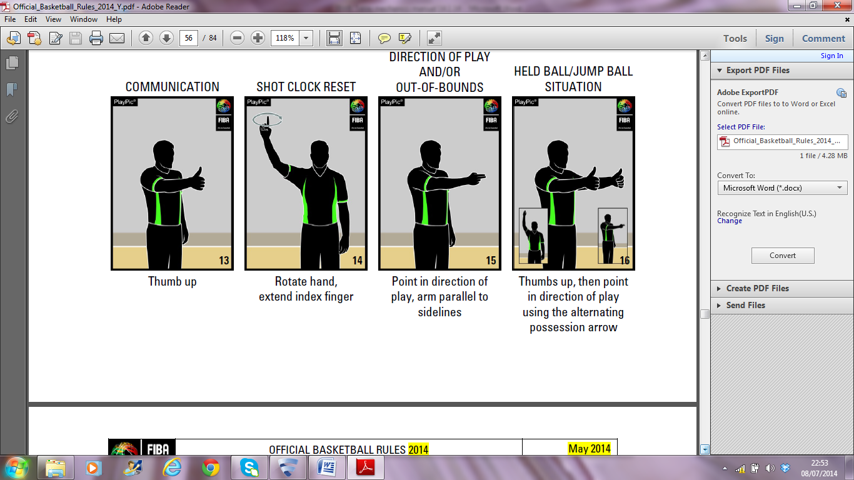

**The Start of the game**

As the ball is touched by a player on court the Timekeeper will chop the time in (signal 3) and simultaneously start the game clock.

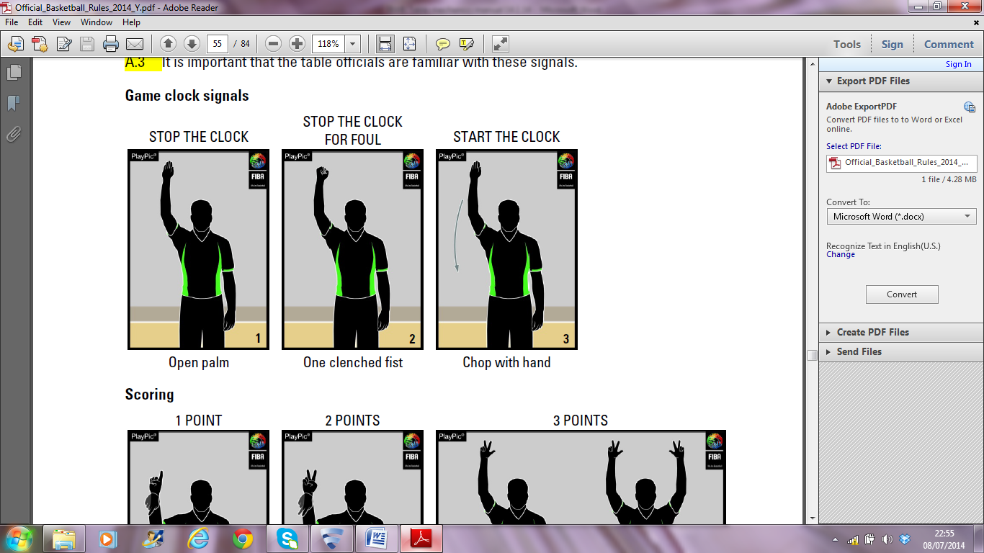

Once control is established the Shot Clock Operator will start the visible shot clock and the Scorer will position the alternating possession arrow in the direction of play for the team on defence.

# During the game

## Scorers Mechanics

### Recording Scores

Slash (**/**) through the resulting score after 2 or 3 point baskets and record the scorer's shirt number in the empty box beside the score. For every 2 point basket scored acknowledge back to the Officials by flagging 2 points successful (signal 5). For each 3 point basket scored acknowledge back to Officials by holding up 3 fingers on your none writing hand (part 1 of signal 6 – 3 point attempt). Note do not use part 2 of signal 6 (3 point successful) as you will not be able to record the basket with both hands in the air. After each point/basket scored confirm the updated score Team A then Team B with the Assistant Scorer verbally for him to cross reference with the visible scoreboard, and other members of the table team. When no Assistant Scorer is present, confirm updated score with the Timekeeper.

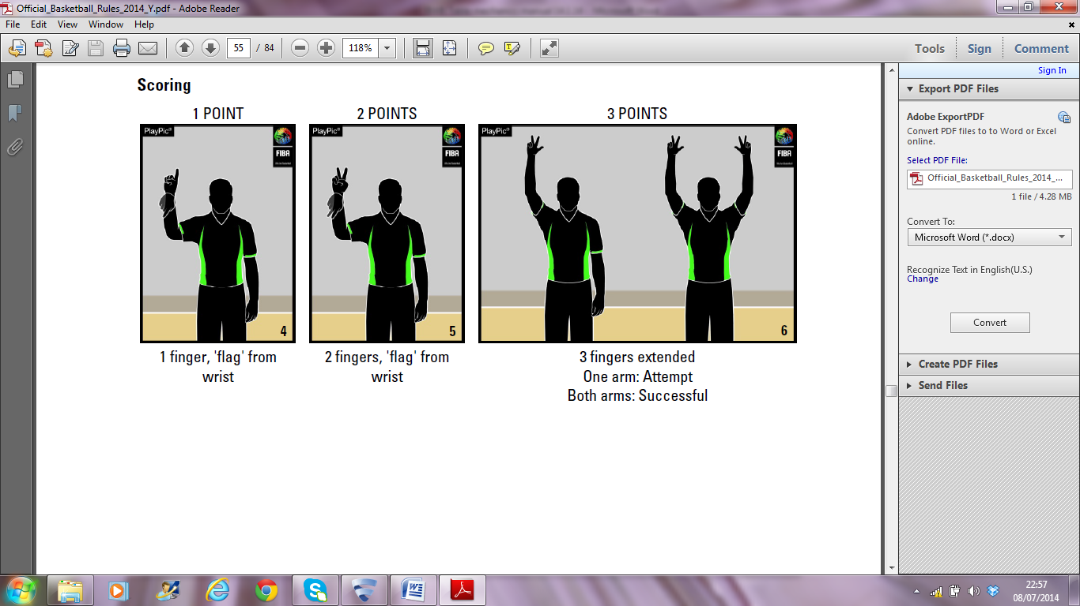

### Free Throw Attempts

During each free throw attempt signal the number of free throws one 1, 2 or 3 as the ball in placed at the disposal of the player for each free throw attempt (signals 54, 55 and 56 respectively but with arm extended so signal is clearly visible (if possible)).

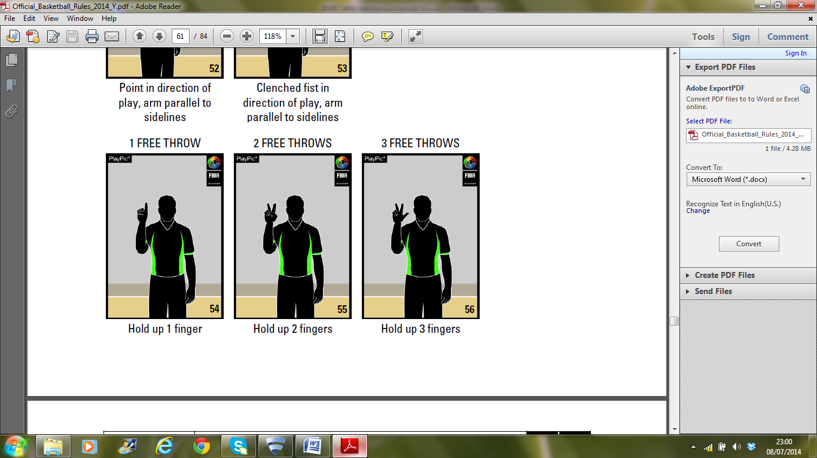

### Recording Free Throws

Dot (**●**) over the score for each 1 point basket scored and record the scorers shirt number in the empty box beside the score. For each 1 point basket scored acknowledge back to the Officials by flagging 1 point (signal 4 but with arm extended so signal is clearly visible (if possible)).

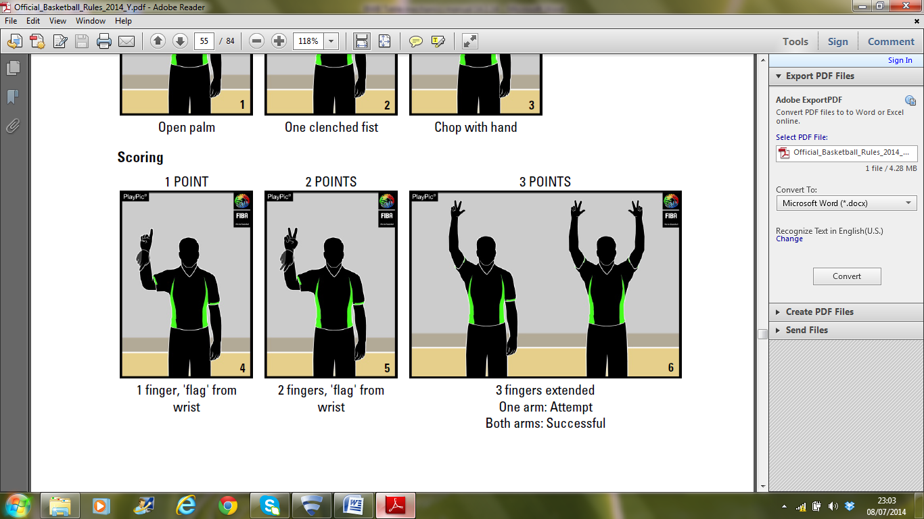

### Recording Player and Team Fouls

Record every player and team foul as described in the Rules. Indicate to the Officials that recording is complete by holding the relevant player foul marker aloft and communicate verbally with the Assistant Scorer. Both teams also need to know how many fouls are progressively charged to their players. When multiple fouls are called at the same time, record the fouls as above in the order that they were signalled however hold aloft the foul marker angled slightly towards that player's bench and verbalise clearly the team colour and player number.

### Recording a Player’s Second Unsportsmanlike or Technical Foul

Should a player receive a second unsportsmanlike or second technical foul (resulting in a disqualification for that player), and the reporting Floor Official not signal the disqualification, the Scorer shall sound his audible signal to obtain the Officials attention and beckon them to the table to verbally inform them.

### Recording the Team’s 4th Foul

Inform the Shot Clock Operator when the home team, and Assistant Scorer when the away team, reaches its 4th foul. Raise 4th team foul marker as the ball is placed at the disposal of the player immediately after the foul. NB. The Shot Clock Operator and Assistant Scorer will actually raise the marker. When no Assistant Scorer is present, the Scorer shall raise the away teams team foul marker.

### Administration of Substitutions

When a player requests a substitution and is ready to enter the playing area, check that he is on the scoresheet. Assuming he is on the scoresheet, at the next substitution opportunity the Scorer shall sound his audible signal to obtain the Officials attention, signal the substitution using signal 7 below, followed by indicating to the team bench area requesting the substitution with an open palm facing the officials. When a player enters the game for the first time the Scorer must indicate the fact by placing a cross (X) against the player’s name in the ‘player in’ column next to the player’s number.

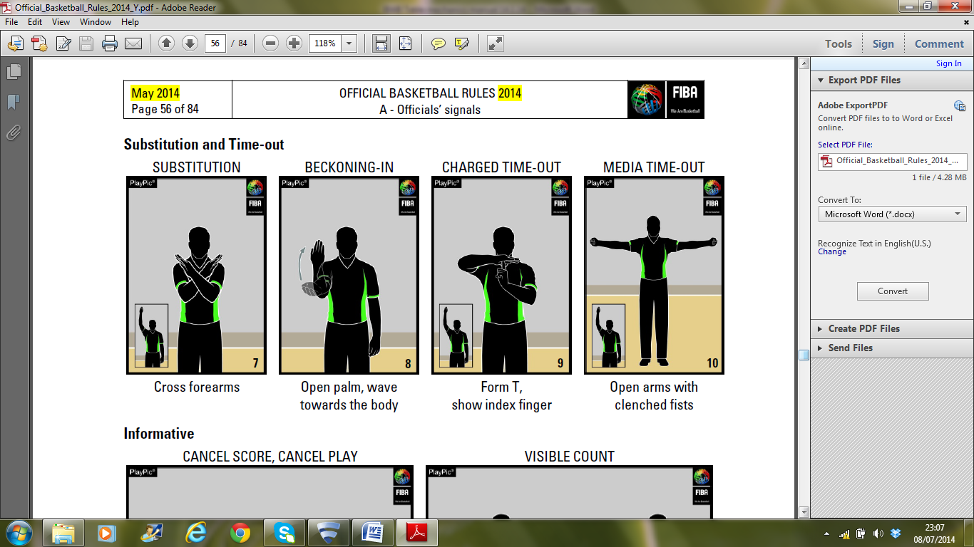

### Administration of a Charged Timeout

When a Coach requests a charged timeout ensure communication is given across all the Table Officials at the next timeout opportunity the Scorer shall sound his audible signal to obtain the Officials attention, signal the timeout using signal 9 below, followed by indicating to the team bench area requesting the timeout with an open palm facing the officials. Record the timeout with the minute that it is administered. Inform the Referee when a Coach has used both timeouts in the first half and all 3 in the second half by signalling the timeout signal with 2 or 3 fingers touching the open palm and pointing to the team bench area of the team.

NOTE: If a Coach requests his first timeout of the 2nd half within the last 2 minutes of the game (2:00 and below on the clock), record the timeout in the second allocated square on the scoresheet and rule out the 1st allotted square (=) on the scoresheet.

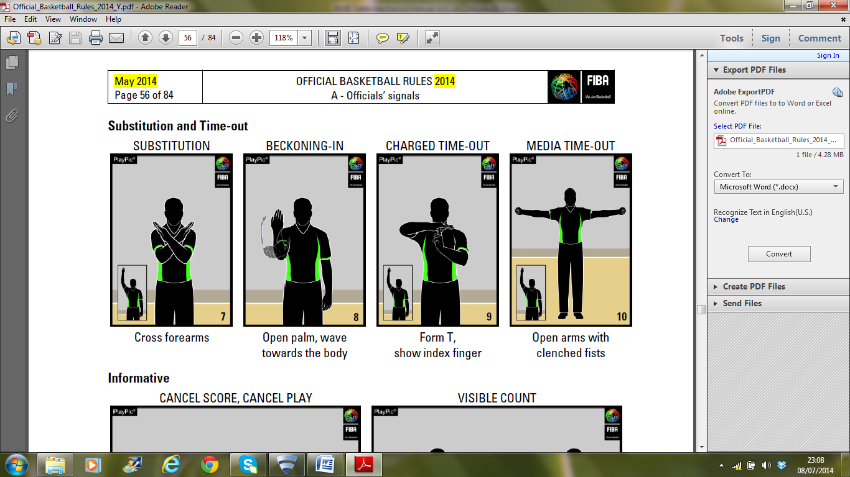

### Held Ball Situations

When a held ball is called hold the arrow (if appropriate) in the direction it is pointing for the Official to see. Confirm the direction of play with the Shot Clock Operator so he can confirm if a reset of the shot clock is required. Do not reverse the arrow on the table top until the ball has been inbounded and the clock started.

### Procedures during a Fight and / or Bench Clearance

Should a fight breakout on court, and / or a bench clearance occur the Scorer must remain focused on the events unfolding on court making notes of any actions of players, coaches and team members, in order to assist the Officials and Commissioner.

### Procedure Team Over points

When a team is discovered to be over points, double check the players on court are those thought with the Assistant Scorer and Commissioner (if present). If the team which is over points is

1. In control of the ball: Stop the game immediately
2. Not in control of the ball and the offensive team will not be placed at a disadvantage: Stop the game immediately
3. Not in control of the ball and the offensive team will be placed at a disadvantage: Wait until the disadvantage has ended before stopping the game.

Sound the audible signal to obtain the Officials attention. Beckon the Referee to the table and inform them of the points total on court.

## Timekeepers Mechanics

### Starting and Stopping the Clock

On every whistle and after every basket in the last 2 minutes of the game, the Timekeeper will stop the clock and signal by raising his hand (signal 1 below). If foul shots are awarded or there is a delay in the game then the Timekeeper can lower his hand. On resuming play, the Timekeeper will check that all of the Table Officials are ready and signal this to the Officials by raising their hand again with arm straight and palm facing the baseline. As the ball is touched by a player on the court He will simultaneously chop the time in and start the game clock (hand signal 3). NB. If no Assistant Scorer is present, during the last 2 minutes of the game, the Timekeeper should administer the clock mechanics of stop/start the clock before updating the scoreboard.

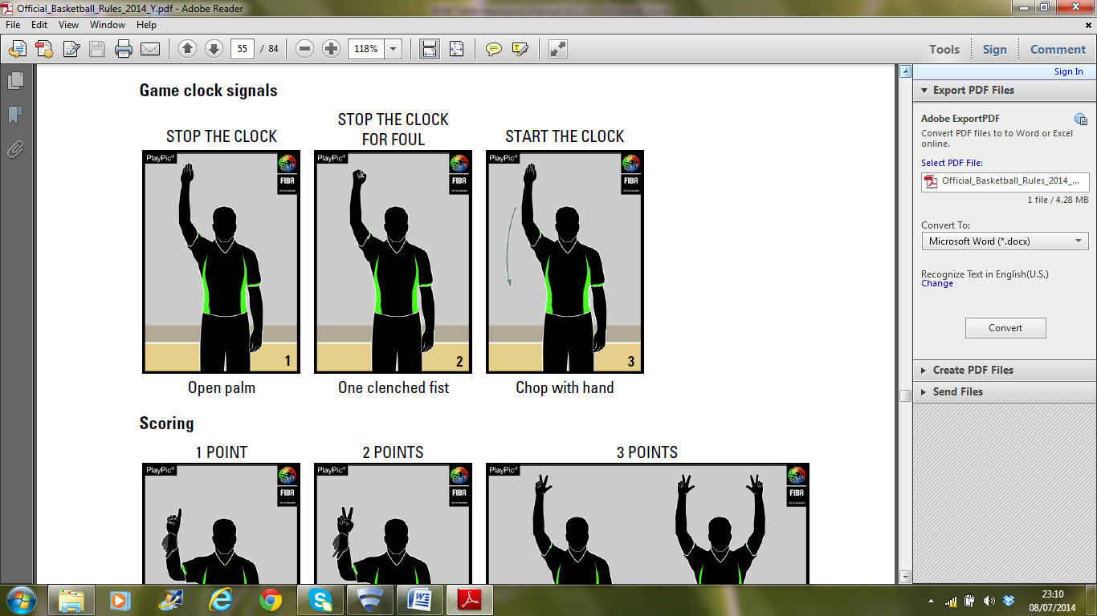

STOP THE CLOCK



Open palm

### Timeout Requests for a Team who concedes a Basket

The Timekeeper will stop the game clock and sound the scoreboards audible signal as the ball passes (and remains) through the ring. If the Officials do not hear the audible signal, make every attempt to get their attention. DO NOT allow the game to continue and restart the clock. Inform the Scorer that the team who have conceded a basket have made a request for a timeout as they may not have seen the request if they were recording the basket made. The Scorer will indicate the timeout request from the appropriate Coach to the Floor Official. This mechanic applies to any request made by the Coach conceding a basket up to the point of the ball being at the disposal of a player for a throw-in.

### Administering a Charged Timeout

Begin the 1 minute timeout on the clock on the Officials whistle. When 50 seconds has elapsed sound the audible signal and present 10 fingers to the Officials. When the full 1 minute has elapsed sound the audible signal to inform the Officials to resume play.

### End of a shot clock timed offence

The Timekeeper will count down aloud the last 10 seconds of a shot clock offence for both the Shot Clock Operator and Scorer to be aware of the time left when the ball is released. Do not watch the ball during this phase of play, focus on the shot clock count down.

### Reset of the Shot Clock in Error (where equipment does not allow you to revert immediately back)

Should the shot clock be reset in error during play the Shot Clock Operator will alert the Timekeeper. The Timekeeper shall continue counting down aloud using the visible game clock above the basket as a guide and sound the audible device should he get to zero before being informed by the Shot Clock Operator of a valid reset on the offence.

### End of the Period

When the game clock has less than 24 seconds left, inform the Shot Clock Operator that it will be the last timed offence of the period. Reinforce this when less than 14 seconds remain.

### Procedures during a Fight and / or Bench Clearance

Should a fight breakout on court, and / or a bench clearance occur, the Timekeeper must remain focused on the events unfolding on court making notes of any actions of players, coaches and team members, in order to assist the Officials and Commissioner report events accurately and apply suitable penalties.

## Shot Clock Operator Mechanics

### Shot Clock / Mechanics

4.3.1.1 The shot clock will be blanked and reset as dictated by the rules (articles 29 and 50). The visual display from shot clocks will not become visible until control has been established and the countdown begins. The visual display will be stopped on every whistle and audibly confirm the time left in the offence to the Scorer and Timekeeper.

4.3.1.2 The shot clock during free throws should be blanked (if possible) and charged with 24 seconds before the first or only free throw is administered.

### Last 10 Seconds of an Offence

The Shot Clock Operator will inform the Timekeeper when the visual shot clock reaches 10 seconds.

### Last 10 Seconds of a Period

Assuming the Shot Clock Operator is not involved in timing an offence he will stand up and position himself behind the Scorer and countdown aloud the 10 seconds and backup the final audible signal on the scoreboard with a second audible device. Do not focus on the game during this time. Remain focused on the game clock. If the Shot Clock Operator is still involved in timing an offence the Assistant Scorer will take on this role.

### Held Ball Situations

Should a held ball be signalled, the Scorer will indicate the direction of play according to the alternating direction arrow. If the team which had possession of the ball remain in control of the ball the Shot Clock Operator will confirm the time remaining on the visual countdown. If team possession changes, he will confirm the reset of the shot clock with the table official team.

### Reset of the Shot Clock in Error (where equipment does not allow you to revert immediately back)

* Should the visible shot clock be reset in error during a stopped clock phase, alert the Officials as soon as possible and reset the visible countdown to the correct time before play resumes.
* Should the visible shot clock be reset in error during play the display has to be left blank; inform the Timekeeper immediately of the time left in the offence so they can continue a verbal countdown. If during this time a valid reset occurs inform the Timekeeper immediately. If the clock is stopped during this time alert the Officials as soon as possible and reset the visible countdown to the correct time before play resumes.

### Procedures during a Fight and / or Bench Clearance

Should a fight breakout on court, and / or a bench clearance occur, the Shot Clock Operator must remain focused on the events unfolding on the home team bench, making notes of any actions of players, coaches and team members entering court, in order to assist the Officials and Commissioner report events accurately and apply suitable penalties.

## Assistant Scorers Mechanics

### Scoreboard Updates

Assuming the scoreboard permits, the Assistant Scorer will update the visual scoreboard with points and fouls as they occur in the game.

### Assisting the Scorer

The Assistant Scorer will carry out any task or duties requested by the Scorer in the pre-game conference.

### Last 10 Seconds on a Period

If the Shot Clock Operator is still involved in timing an offence during the last 10 seconds of a period, the Assistant Scorer will stand up and position himself behind the Scorer and countdown aloud the last 10 seconds and backup the final audible signal on the scoreboard with a second audible device. Do not focus on the game during this time. Remain focused on the game clock. However do not forget to add scores and fouls to the visual scoreboard if the equipment permits.

### Procedures during a Fight and / or Bench Clearance

Should a fight breakout on court, and / or a bench clearance occur, the Assistant Scorer must remain focused on the events unfolding on the away team bench, making notes of any actions of players, coaches and team members entering court, in order to assist the Officials and Commissioner report events accurately and apply suitable penalties.

### Procedure Team Over Points

If a team is believed to be over points the Assistant Scorer should assist the Scorer and Commissioner (if present) by confirming the 5 players on court.

# Intervals of play

## Scorers Duties

* At the end of each period enter the score of that period in the proper section in the lower part of the scoresheet using the administration colour ink (i.e. dark ink).
* Request the team foul markers to be lowered (if required).
* Make the scoresheet available to the Commissioner and Referee (if requested).
* Hold the arrow (if appropriate) pointing in the direction of play clearly for the Officials to see in order to execute the start of another period.

## Assistant Scorers Duties

* Lower the team foul markers for the away team (if required).
* Check the personal fouls against the scoresheet.
* Be ready to communicate any substitution requests from the away bench.

## Timekeepers Duties

* Time the 2 minute interval of play. Inform the Officials when 90 seconds have elapsed by sounding your sounding device.
* At the end of the 2 minute interval reset the visible game clock ready to begin a new period of 10 minutes.

## Shot Clock Operators Duties

* Lower the team foul markers for the home team (if required).
* Be ready to communicate any substitution requests from the home bench.

# Half Time Duties (in addition to interval of play)

## Scorers Duties

* At the end of the second period, draw a thick line between the player personal foul spaces that have been used and those that have not been used in the period coloured ink.
* With the Referee and / or Commissioner present reverse the alternating possession arrow. This should be done immediately after the end of the second period.

## Timekeepers Duties

* Time the 15 minute interval of play. When 3 minutes are remaining inform the Referee so that they may alert the teams involved. With 90 seconds remaining inform the Referee so that they may alert the teams.
* At the end of the 15 minute interval reset the visible game clock to begin a new period of 10 minutes.

# End of Game

Be aware of the game situation. If the game has been a hard fought close game it may be preferable for the Officials to vacate the floor immediately after the final buzzer. In these situations the Table Officials should take their belongings and go to the Official’s room to complete the administration of the game. If this is not the case then complete administration of the game at the table.

## All Table Officials

* Print name on scoresheet and sign to the right.
* Remain at the table (or Official’s room) until released by the Commissioner or game organising body.
* Check that all equipment provided for the game is visible on the table.

## Scorers Duties

* Complete the scoresheet as required under the rules.

## Game Series

In games which involve a 2 games total points series (aggregate score). Each scoresheet will be an accurate record of each individual game.

## Tied Games

In a game which is part of a 2 game total points series (aggregate score) which results in a tied score, the name on the winning team will be recorded as ------------.